Teach and Lead in Boston

March 27, 2014

Diversity Career Fair for Teachers - March 27
You can make a difference. Teaching in Boston is a guaranteed way for you to impact the lives of our racially, culturally, and linguistically diverse students and their families.

Thursday, March 27
4:00 - 7:00 p.m.
Boston Latin School (details below)

Register as an Applicant Today: Go towww.teachboston.org and click on "Teach in Boston."

Teach and Lead in Boston - April 2
Are you an aspiring teacher looking to launch your career? Are you a current teacherinterested in leading from the classroom?

This spring provides an unprecedented opportunity to apply to teach in one of the most attractive and diverse urban districts in the country. More than 800 teaching positions are available for outstanding current and aspiring teachers who want to teach in Boston Public Schools.

Join us on Wednesday, April 2 to learn how you can teach, grow, and lead in Boston Public Schools:

- Talk with teacher leaders on school hiring committees
- Explore teacher leadership opportunities such asTeach Plus Fellows, BPS Lead Teacher, T3 Teacher Leader, National Board Certified teacher, and more
Wednesday, April 2
4:30 - 6:30 p.m.
Boston Latin School (details below)

Explore open positions now!

Attendees who arrive by 5 p.m. will be entered into a raffle to win gift certificates to Myers + Chang, the Blarney Stone, and Lincoln Tavern & Restaurant.

RSVP and invite fellow teachers/teaching candidates.

Boston Latin School - Location of Both Events
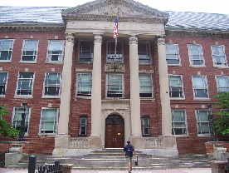
Boston Latin School (School Library)
78 Avenue Louis Pasteur
Boston, MA 02115

(Off of Huntington Ave., at the corner of Ave. Louis Pasteur and Longwood Ave.)

Free Parking available for teaching candidates in the school parking lot. The school is easily accessible from the Green and Orange Lines. Click here for directions.

